Test Case: tc006_SPX_Dev5_Crear_Requisicion_Spot_Tipo_Cobro_Proyect_Urgent
Step 1 - Enter username and password and click to button Enter: Credentials Entered
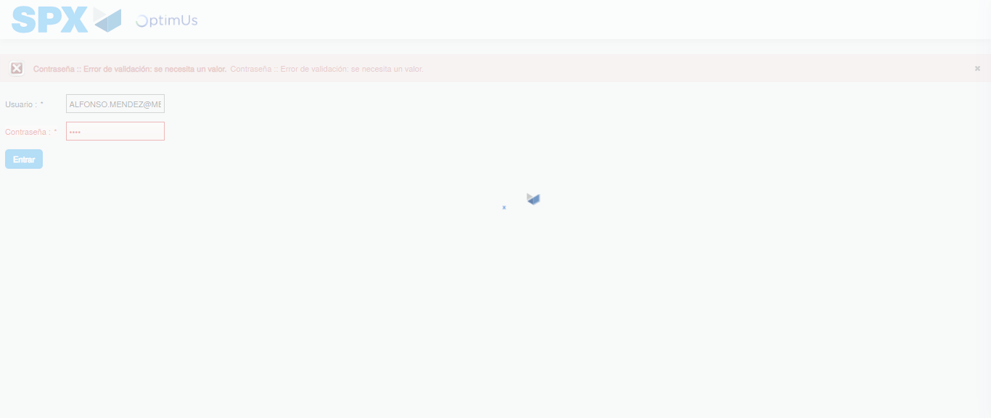Image file-name: QC_Testing-tc006_SPX_Dev5_Crear_Requisicion_Spot_Tipo_Cobro_Proyect_Urgent-1783379747988

Step 2 - Select to UEN and Access to Spot Buy Requisitions : UEN Correctly selected and Correct access
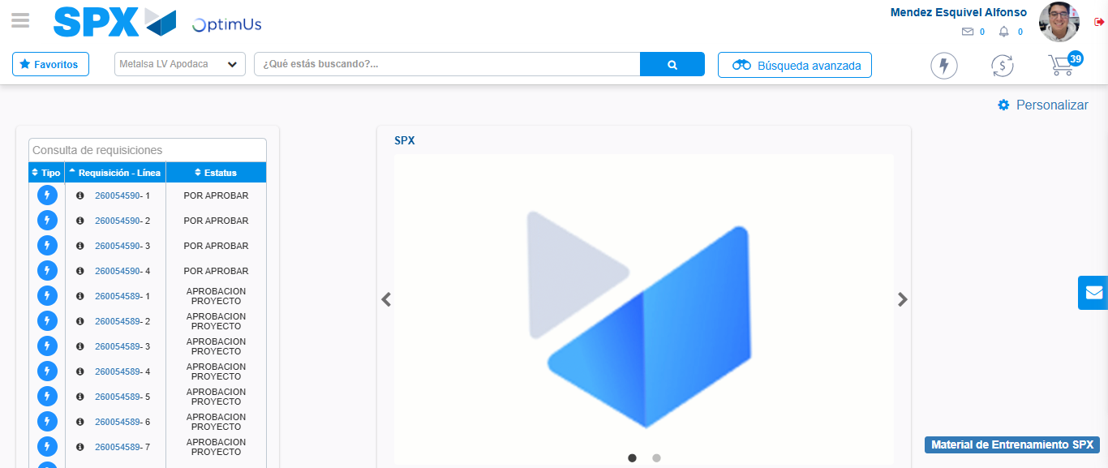Image file-name: QC_Testing-tc006_SPX_Dev5_Crear_Requisicion_Spot_Tipo_Cobro_Proyect_Urgent-1783379773949

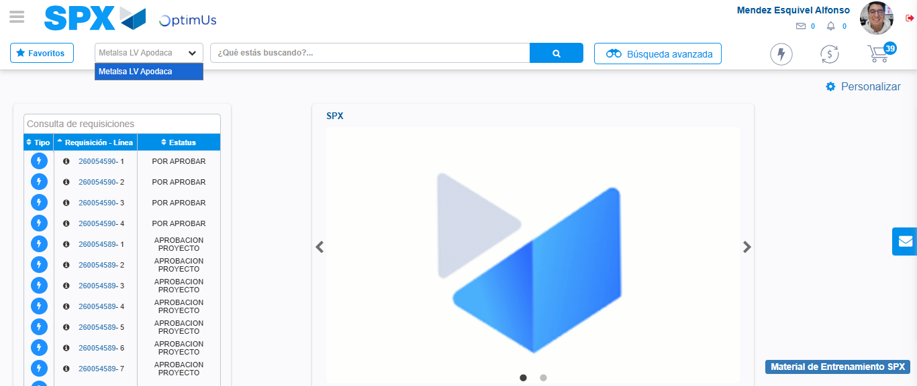Image file-name: QC_Testing-tc006_SPX_Dev5_Crear_Requisicion_Spot_Tipo_Cobro_Proyect_Urgent-1783379776407

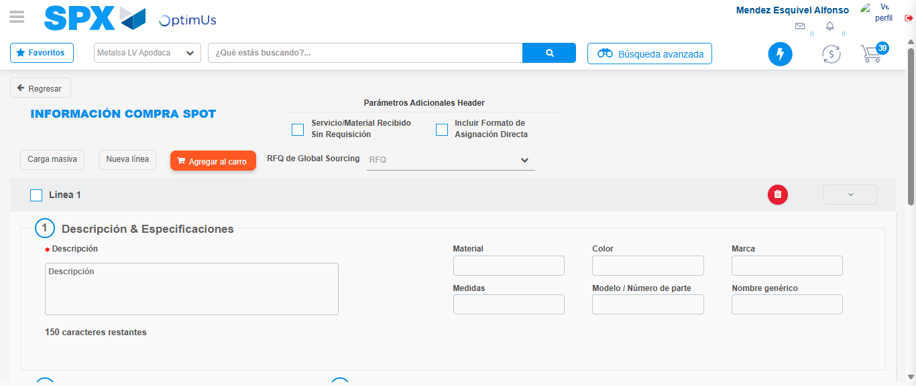Image file-name: QC_Testing-tc006_SPX_Dev5_Crear_Requisicion_Spot_Tipo_Cobro_Proyect_Urgent-1783379797392

Step 3 - Data Capture Spot Buy Requisition: Data captured correctly
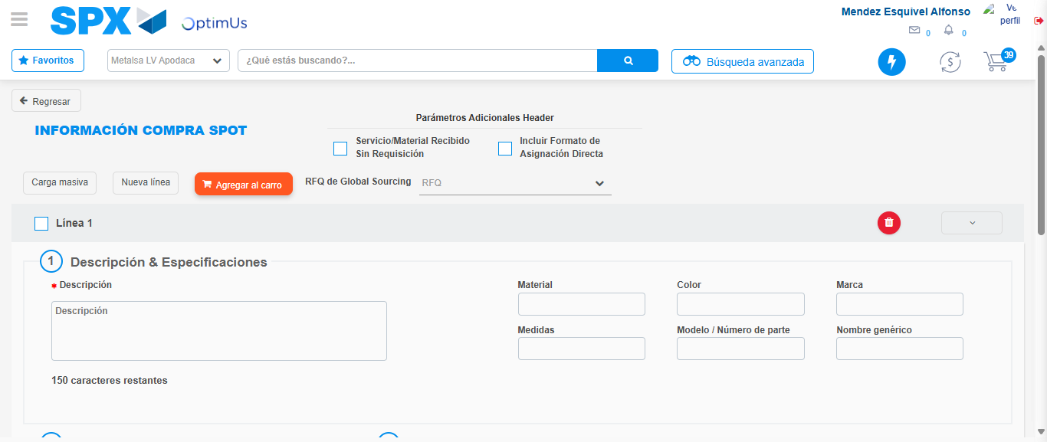Image file-name: QC_Testing-tc006_SPX_Dev5_Crear_Requisicion_Spot_Tipo_Cobro_Proyect_Urgent-1783379797659

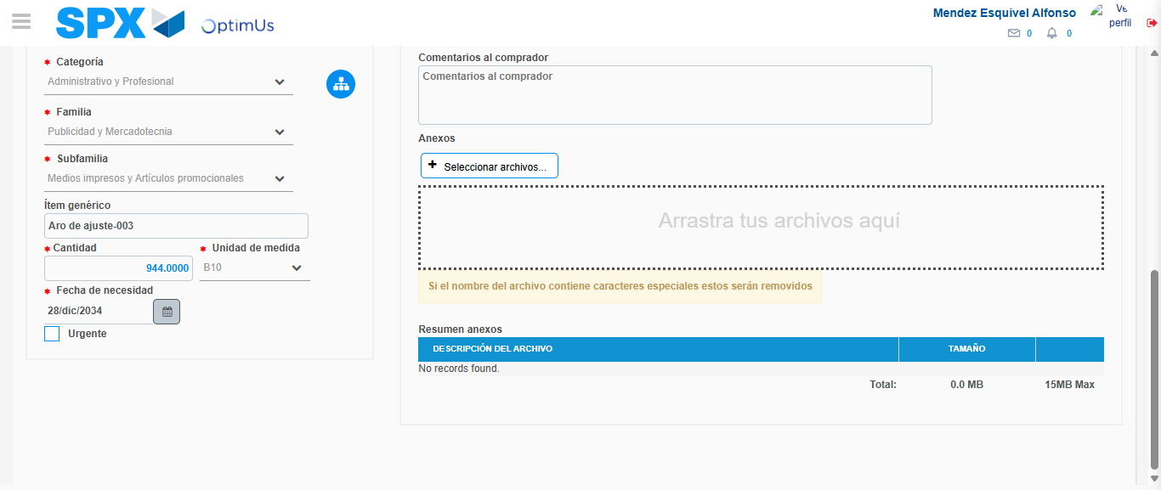Image file-name: QC_Testing-tc006_SPX_Dev5_Crear_Requisicion_Spot_Tipo_Cobro_Proyect_Urgent-1783379807384

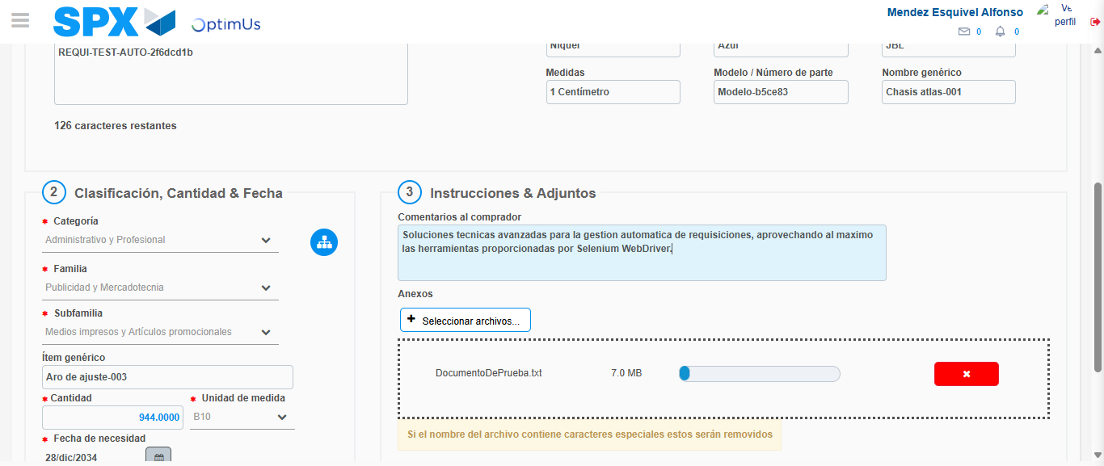Image file-name: QC_Testing-tc006_SPX_Dev5_Crear_Requisicion_Spot_Tipo_Cobro_Proyect_Urgent-1783379808134

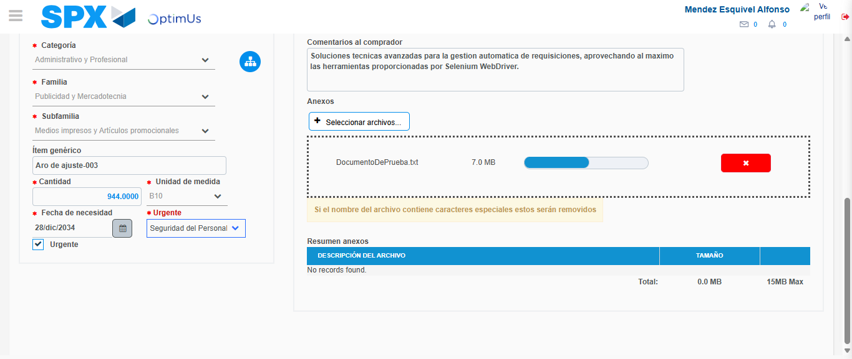Image file-name: QC_Testing-tc006_SPX_Dev5_Crear_Requisicion_Spot_Tipo_Cobro_Proyect_Urgent-1783379811212

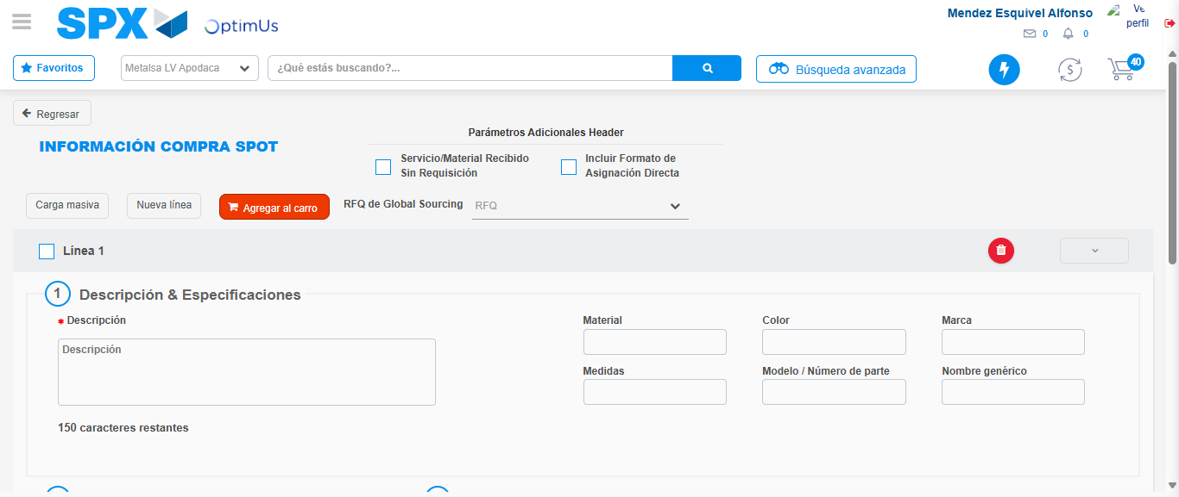Image file-name: QC_Testing-tc006_SPX_Dev5_Crear_Requisicion_Spot_Tipo_Cobro_Proyect_Urgent-1783379818568

Step 7 - Return to Main Page SPX : Return to Main Page SPX
Image file-name: QC_Testing-tc006_SPX_Dev5_Crear_Requisicion_Spot_Tipo_Cobro_Proyect_Urgent-1783379773949

Image file-name: QC_Testing-tc006_SPX_Dev5_Crear_Requisicion_Spot_Tipo_Cobro_Proyect_Urgent-1783379776407

Image file-name: QC_Testing-tc006_SPX_Dev5_Crear_Requisicion_Spot_Tipo_Cobro_Proyect_Urgent-1783379797392

Image file-name: QC_Testing-tc006_SPX_Dev5_Crear_Requisicion_Spot_Tipo_Cobro_Proyect_Urgent-1783379820807

Image file-name: QC_Testing-tc006_SPX_Dev5_Crear_Requisicion_Spot_Tipo_Cobro_Proyect_Urgent-1783379821011

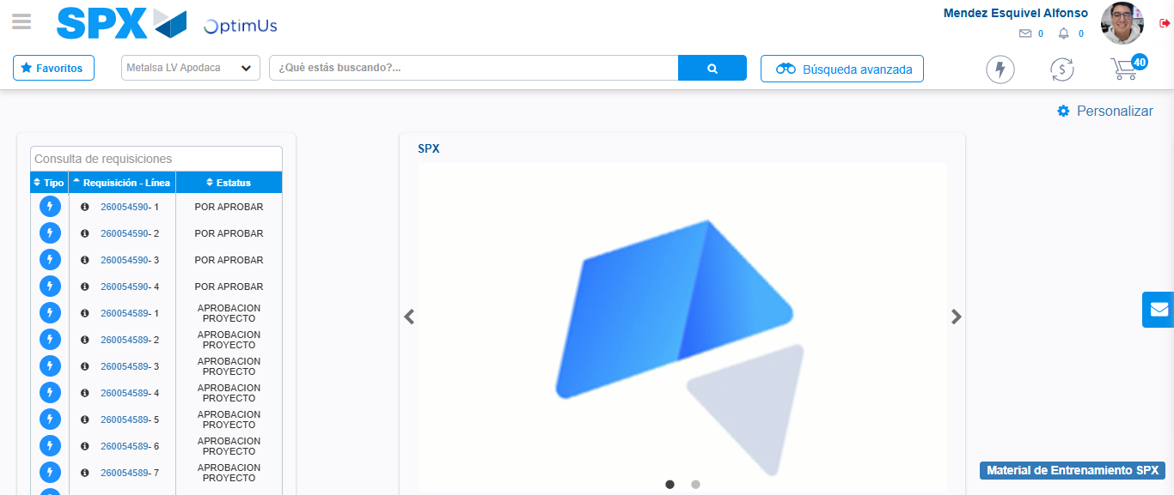Image file-name: QC_Testing-tc006_SPX_Dev5_Crear_Requisicion_Spot_Tipo_Cobro_Proyect_Urgent-1783379842004

Step 8 - Log Out : Log Out SPX
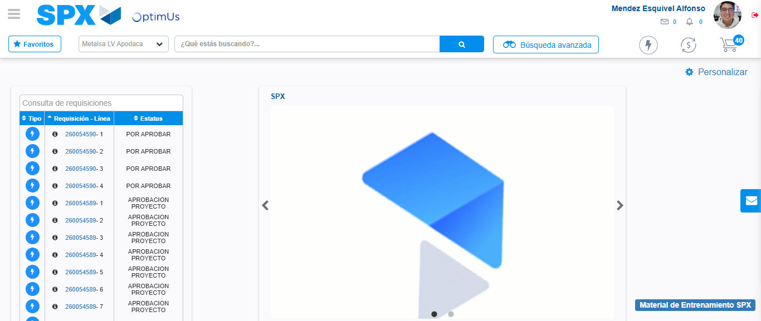Image file-name: QC_Testing-tc006_SPX_Dev5_Crear_Requisicion_Spot_Tipo_Cobro_Proyect_Urgent-1783379842233

